**Project title: Online Price Lists Management**

**Project ID: BTS-730 GRP 5 (LAB 3)**

**Authors**: Oluwaseyi Aketepe(134971159) Khai Phan (100901164), Marco Rico (111708178), Julian Boyko (111404174)

**Brief description** A small retail company sells its product via a Portal application. Product price lists are located on the Portal server in a Relational Database. The retail company wants to maintain price lists online using a custom application developed for this purpose. Regular operations, such as making updates, delete, or insert records should be implemented. The application should be located on the Portal application server, with access provided to the support personnel. Standard access control facilities also need to be developed.

The company is going to outsource software testing to another small company that provides a testing service. The software will be sent to the service provider for testing.

**First Task (May 31st, 2020)**

For your group project, work on the initial project definition to be presented to the company management.

The presentation is to be prepared as an MS Word or PowerPoint document. To the best of your ability, draft the content for the following sections (see the sample of Project Definition Doc):

* The problem outline
* The expected outcome in terms of business/ security improvements, as well as other benefits if applicable
* Suggested Project Sponsor(s)
* Suggested Project Stakeholder(s)

In addition, complete the following tasks using the template posted in the lab task description. You also need to work with the textbook in order to obtain a better understanding of the document contents.

**Additional tasks:**

* Create a Stakeholder register. The template is posted. Consult the Textbook, Chap 3
* Create a RACI Matrix. The template is posted. Consult the textbook, Chapter 9

**Brief description** A small retail company sells its product via a Portal application. Product price lists are located on the Portal server in a Relational Database. The retail company wants to maintain price lists online using a custom application developed for this purpose. Regular operations, such as making updates, delete, or insert records should be implemented. The application should be located on the Portal application server, with access provided to the support personnel. Standard access control facilities also need to be developed.

The company is going to outsource software testing to another small company that provides a testing service. The software will be sent to the service provider for testing.

Khai Phan

1. **The Problem outline**

* Customer is having a demand for a software that they can control and maintain the price. Different people will have different levels of authorization and can control different parts of the software. The minimal requirement for the software is to have an Update for the price, Delete the old price and Insert the new price.
* The new application will be placed in Portal Application where it will link to the Portal Server to fetch the database.
* After the software has been completed, another company will be used to trial the software for any unexpected outcome or bug before using it in the main company.

1. **The expected outcome in terms of business/security improvements, as well as other benefits, if applicable**

* In the end, when the application is finally completed, another company will be testing out for its functionality and workability. This way, the main company can easily avoid the risk of software failing or the problems they might face during usage.

Julian Boyko

1. **Suggested Project Sponsor(s)**

Before I can suggest the project sponsor it’s important to note what a project sponsor is. The Project Sponsor is considered a part of the Project Stakeholders. And a stakeholder is any sort of person that is involved or affected by a project being followed out. This encompasses *project sponsors,* project team, support staff, customers, users, suppliers etc. In addition to that, the Project Sponsor is generally the person who owns the project. So because of that, in this instance, the Project Sponsor would be the small retail company. The reason being is because they are the major stakeholder in the project, and they own the retail store and are the company launching the project, therefore making them the project sponsor.

Marco Rico

1. **Suggested Project Stakeholder(s):**

For identifying stakeholders within our situation here, looking at key factors for each person will easily help us to identify who will be a stakeholder. One is to see if they are a sponsor to the project, being a sponsor can also mean you are a stakeholder. Another is to see if a person has any sort of gain or interest once the project is complete. Also, seeing if the person can have a positive or negative effect on the execution of the project can make them a stakeholder. When looking, we can identify some common internal stakeholders within the company. This includes project managers who are overviewing the portal application. Project team members who work within the portal application and also in storing customer information. Now looking at external stakeholders for the project, a main focus is on the company we are outsourcing for testing. This company will have for managing this its own set of project managers and team members to execute the testing. It can also be seen in the scenario and our definition of a stakeholder that customers will be a stakeholder as they have an interest in the final project. Also suppliers will be as they have an interest in the final project.

1. **Create a Stakeholder register. The template is posted. Consult the Textbook, Chap 3**

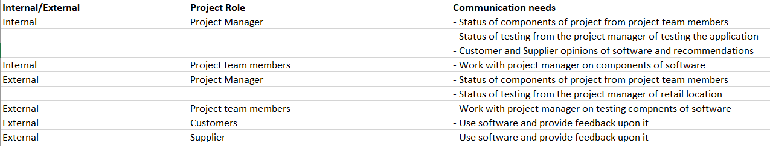

1. **Create a RACI Matrix. The template is posted. Consult the Textbook, Chap 9**

